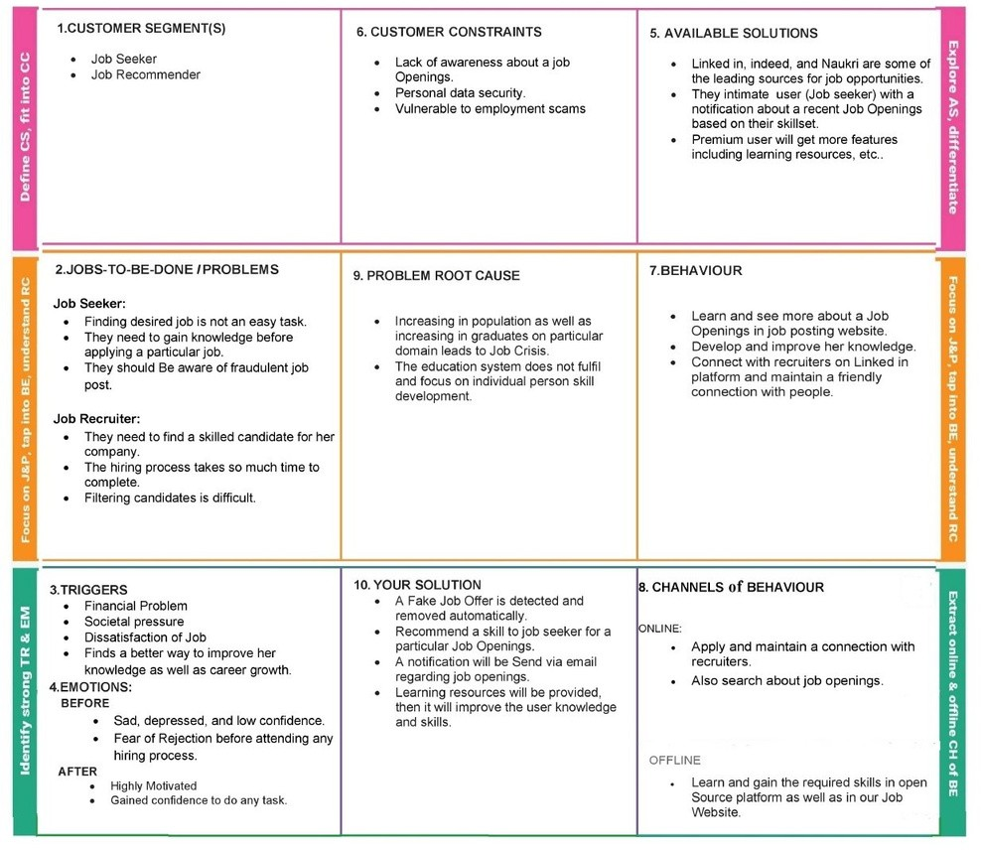 Problem Solution Fit Skill / Job Recommender ApplicationPNT2022TMID44667